Thank you for your interest in hosting a No Man’s Land travelling exhibit. Please complete this form below and return it with any requested materials to Cane River National Heritage Area, Inc. (CRNHA)
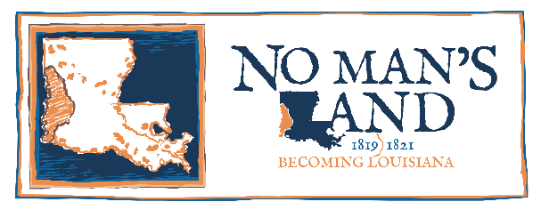

Preferred Dates for exhibit presentation (4-6 week intervals)

Name of borrowing institution

Address

City State Zip Code

Contact

Telephone Number Email Fax

If the exhibit will be displayed at a different location or more than one institution will be involved in the presentation of the exhibit, please complete the following.

Name of borrowing institution

Address

City State Zip Code

Contact

Telephone Number Email Fax

Why does your institution want to host this exhibit?

What is your institution’s annual attendance? .

What kind of programming would your institution plan in conjunction with exhibit?

Do you have, or anticipate any, community partners, corporate or media sponsors for the exhibit?

You may email these materials to lschlatre@canerivernha.org, mail, or fax to them at:

Cane River National Heritage Area, Inc.
Attn: Logan Schlatre
1115 Washington Street
Natchitoches, LA 71457
T. (318)356-5555
F. (318)356-8222

*Hosts will be required to pay a $25 travel fee to cover the costs associated with transporting the exhibit; checks should be made out to Cane River National Heritage Area, Inc. and can either be mailed to the address above or received upon the exhibit’s arrival.
*This exhibit is 8 feet tall, requiring all hosts to have an assembly and display area that are at least 9 feet tall.

CRNHA is a Not for Profit organization, tasked with managing the congressionally designated cultural region which encapsulates the historic and diverse cultural landscape of Cane River. CRNHA has partnered with the No Man’s Land Bicentennial Committee to help celebrate the 200 year anniversary of No Man’s Land through the creation of events and this traveling exhibit with the goal of helping shed light on this dynamic and exciting period of Louisiana history.
For Office Use Only
Approved Dates: Approved by: Date:

Previous Location: Next Location:

